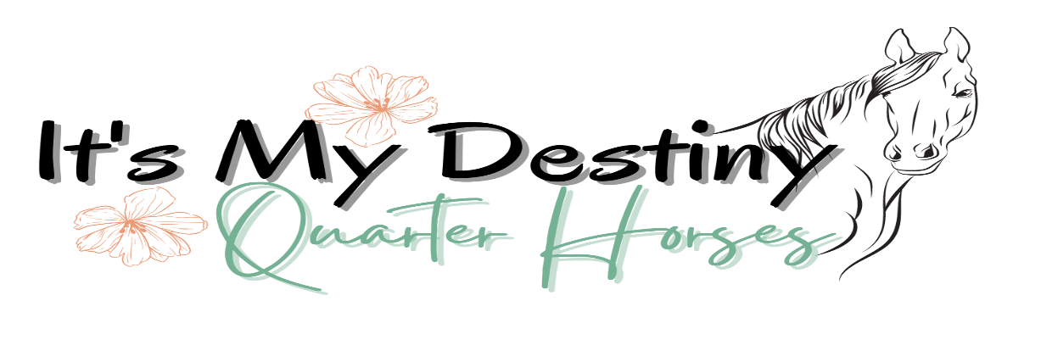

Live Foal Guarantee Breeding Contract for:
______________________________ (Live Cover)
U.S. • Contract is for the 2021 Breeding Season

TERMS AND CONDITIONS
Mare Owner Name:_______________________________________________________________________________Phone:_______________________________________________________________________________
Address:______________________________________________________________________________
Email: ________________________________________________, hereby agrees to breed the _________ (age), _______________________________ (breed) ____________________________________ (registration number),
Mare named __________________________________________________________ to the Stallion named above managed for breeding via live cover in North America by IMD Quarter Horses.
ALL breeding under this Contract is to be through LIVE COVER from the above-named Stallion. Effort will be made by IMD Quarter Horses for a total of three heat cycles to get said mare to conceive. Mare owner holds IMD Quarter Horses harmless if mare fails to conceive during the breeding season. Mare must be halter broken, and with no hind shoes. If IMD Quarter Horses deems mare too difficult to handle she will not be live covered. Early pregnancy scanning at 14 days is recommended in order to arrange for additional live cover breeding done in a timely manner. We require MARE OWNER and Veterinarian to use the entire length of the heat cycle to MAXIMIZE chance of a confirmed pregnancy. MARE OWNER is responsible for payment of breeding fee, booking fee, mare care and veterinary cost.
MARE OWNER agrees to pay $____________, in full, in advance, as well as any additional costs for handling ($75 one time).
MARE OWNER must return signed copy of this contract, the attached Mare ID Form, and the breeding fee via US Post Office(mail), email scan or drop off to IMD Quarter Horses (information above).
MARE OWNER also understands that in order to retain rebreeding rights under the Live Foal guarantee, the completed and signed Veterinary Certificate of confirmed Pregnancy Examinations must be returned at the completion of the current breeding season (2021).
1.) IMD Quarter Horses agrees that if the breeding fee is paid, and the above named MARE does not deliver a live foal that can stand and nurse from this breeding with the above named Stallion, the breeding agreement will be carried forward for a second breeding season. The Breeding fee will only be carried forward ONE Season, and thereafter this contract shall be deemed fulfilled even if above named MARE (or her substitute; see Par.2) still fails to conceive or deliver a live foal the subsequent season. Once a live foal (or foals) has been delivered, and that foal or foals can stand and nurse unassisted, this contract has been fulfilled in its entirety by IMD Quarter Horses.
2.) Should above named MARE fail to conceive and carry a pregnancy the first season, substitution of another mare in her place may be allowed by agreement only, with IMD Quarter Horses.
3.) The breeding fee will be carried forward, and Live Foal Guarantee is valid ONLY if MARE Owner has properly maintained the health of the MARE, and verifies the MARE’s pregnancy loss, stillbirth, or newborn foal death by providing IMD Quarter Horses with an original, signed and dated Veterinary Certificate, on the Veterinarian’s own Letterhead, clearly stating the following:
• Identification of the MARE
• Verification of the loss of pregnancy or “No foal”
• Autopsy or other pertinent examination of MARE, foal, and/or placenta with explanation if possible, for the loss
• Verification that, in the Veterinarian’s best judgment, the MARE was maintained in a reasonable state of health and in good conditions, including all vaccinations and deworming as recommended by the Veterinarian, including but not limited to vaccination against Rhinopneumonitis, and that monitoring of the mare around the time of foaling was adequate enough to reasonably detect and attend to any foaling difficulties.
IMD Quarter Horses must receive this certificate within 30 days of the discovery of the mare’s pregnancy loss or foal death, and in any case prior to further rebreeding of MARE or any semen shipment to MARE.
4.) PREGNANCY STATUS: MARE OWNER agrees to submit to IMD Quarter Horses confirmation of the MARE’s pregnancy at 14 - 16 days post ovulation and 55 - 60 days post ovulation. The completed MARE Passport must be received by IMD Quarter Horses not later than September 15th of the Contract Year.
5.) BREEDING CERTIFICATE: Upon written confirmation of pregnancy at 60 days, IMD Quarter Horses will issue a Breeding Certificate for the appropriate registry.
6.) TERM AND TERMINATION: This agreement is valid for TWO breeding seasons or until both parties have met, they obligations hereunder.
7.) HOLD HARMLESS: MARE OWNER assumes all responsibility for the care, custody, control, and condition of their MARE throughout the breeding, pregnancy, foaling and suckling period, including all veterinary and other additional costs of breeding the MARE, and assumes all risk or damage to their MARE and to any resulting foal, whether by death, disease, injury, infection or otherwise. MARE OWNER agrees to waive any claims against, indemnify, release and hold harmless IMD Quarter Horses, their stock, IMD Quarter Horses management, agents, assigns, employees from any claims, demands, damages, actions, suits, attorney’s fees and costs, obligations or liabilities of any kind that are in any way related to the MARE or to the breeding or Live Coverage of the MARE.
8.) BINDING CONTRACT: This shall be a binding contract upon both parties when signed, binding on all heirs and assigns. The MARE OWNER may not assign this Contract, or any interest in this Contract, to anyone else. This agreement stands in its entirety and may not be changed, modified, or amended in whole or in part. This Contract shall be governed by and construed under the Laws of the State of Minnesota.

IN WITNESS WHEREOF, the Parties have entered into this Contract on the __________ day of _______________________________, 2020.

IMD Quarter Horses MARE OWNER

By:___________________________________________ By:____________________________________
Desirae L. Doan, IMD Quarter Horses

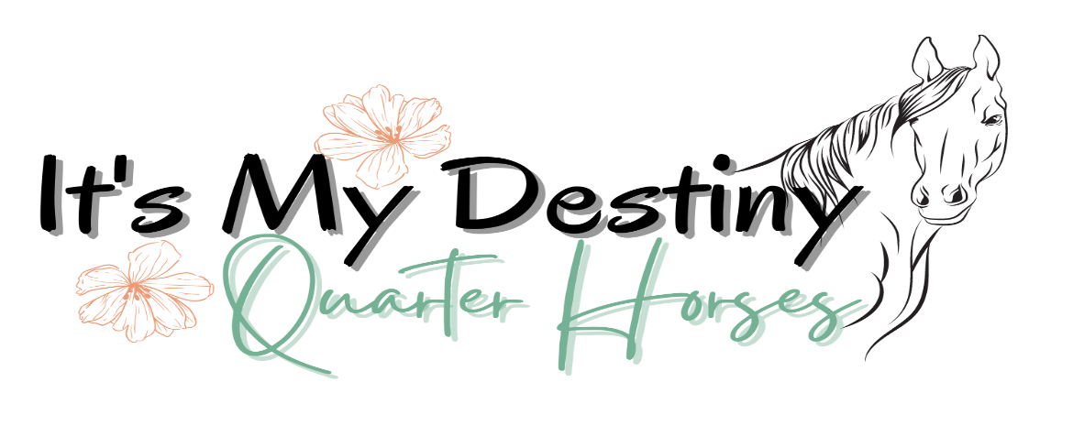
12405 State Hwy 91, Lismore, Mn 56155
715-619-1180
IMDquaterhorses@gmail.com • www.IMDQuarterHorses.com

PAYMENT
The Breeding Fee may be paid by check or credit card.
Name on Card:________________________________________________________________________
Credit Card #:______________________________ Exp. Date: ________________ CID Code: _________
Billing Address for Cardholder:___________________________________________________________
Signature of Cardholder:________________________________________________________________

PLEASE INITIAL YOUR SELECTION:
____________ I am enclosing payment for the breeding by check.
OR
____________ Charge the Breeding Fee to my credit card at this time.

